**Physics 20 - Lesson 17**

**Vertical Forces and Inclines – Answer Key**

Possible 81 / 71

1) 2 marks each for a total of 14 marks

A. Static

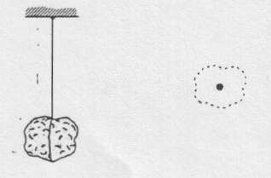

FN

Fg

B. Static

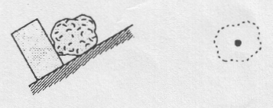

Fblock on rock

FN

Fg

C. Sliding without friction.

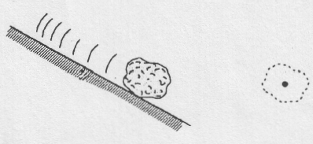

D. Static friction prevents sliding.

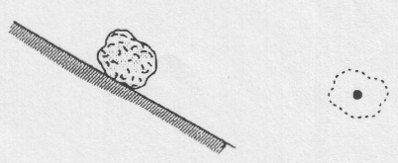

Ff

FN

FN

Fg

Fg

F. Tied to a rope and pulled straight upward. Accelerating upward at 9.81 m/s2 . No friction.

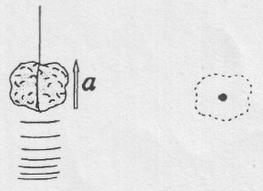

E. Static

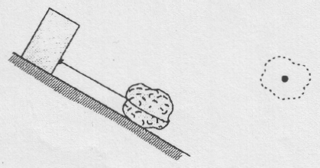

FN

FT

FT

Fg

Fg

G. Tied to a rope and pulled straight downward. Accelerating downward at 19.62 m/s2. No friction.

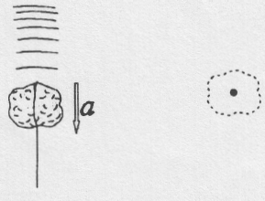

Fg

2)

FT

FT



Constant velocity 

/5



Thrust ()





3)

/6



4)

150N

150N

360N

75N



/6



5)

d)



a)



FT



/11

Since constant velocity is dynamically the same as zero velocity, (b) and (c) are the same as (a).

e)



b)

c)



6)







/4



7)

b)







a)



Bonus

/10

c) If the cable snaps 



(-)

(+)













Friction Force



Acceleraton



8)

/8

9)





(-)

(+)

/8









(+)

(–)













Friction Force



Acceleraton



10a)

/6

10b) Refer to #10a

The frictional force acts in the opposite direction









/3